From Tulipland to Roseland… and Back
A 170-Year Adventure
by Jill Eenigenburg

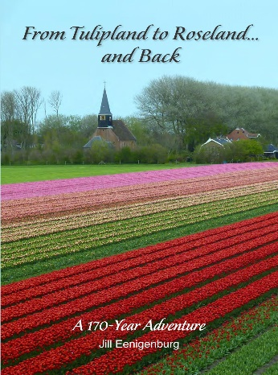

The tragic story of the harrowing voyage to America in 1849 by a group of Dutch immigrants – including our Eenigenburg ancestors – and their heroic efforts to tame the wild wilderness that became Roseland in Chicago. This 200-page book is loaded with historic visuals – some never-before published – that bring the journey and the first 50 years of the settlement to life.

Plus, 175 years later, the relationship with the tiny Dutch village of Eenigenburg they departed has been rekindled – culminating in the creation of a charming museum within its boundaries.

A must read for members of the Eenigenburg family, descendants of the other immigrants, and anyone interested in the early history of the area.

_______________________________________________________________
BOOK ORDER FORM
If you missed the opportunity to order this book at the reunion, there is still time.
ORDERS NEED TO BE PLACED BEFORE JULY 22, 2024.

PAYMENT OPTIONS:
Books are offered at cost - $25 including U.S. postage.
MAIL your check to: Jill Eenigenburg, 14504 SE 47th Place, Bellevue, WA 98006
IMPORTANT: Email jilleenig@aol.com to be sure your order is received before 7/22/24
ZELLE payment to Jill Eenigenburg at: jilleenig@aol.com or 206-619-4477
VENMO payment to: @JillEenigenburg or 206-619-4477

PLEASE SEND MY BOOK(S) TO:
Name: _____________________________________________________________________________________

Mailing address: ____________________________________________________________________________
____________________________________________________________________________
Email address: _________________________________________Phone number: _____________________
No. of Copies: ___________________________

You can also scan your completed order form and email to: jilleenig@aol.com
A tracking number will be emailed when books ship.
Please allow up to 3 weeks from the deadline to receive your books.

